**Industrial Internship Report on**

**Banking Information System**

**Prepared by**

**[Shubham Kumar Singh]**

|  |
| --- |
| *Executive Summary* |
| This report provides details of the Industrial Internship provided by upSkill Campus and The IoT Academy in collaboration with Industrial Partner UniConverge Technologies Pvt Ltd (UCT).  This internship was focused on a project/problem statement provided by UCT. We had to finish the project including the report in 6 weeks’ time.  My project was a Banking Information System that provides a working preview of the key functionalities of a real banking system. The prototype should demonstrate the core features and flow of the system, showcasing its functionality and usability.  This internship gave me a very good opportunity to get exposure to Industrial problems and design/implement solution for that. It was an overall great experience to have this internship. |

**Banking Information System**

TABLE OF CONTENTS

1 Preface……………………………………………………………………………………………………………….. 4

2 Introduction………………………………………………………………………………………………………… 6

2.1 About UniConverge Technologies Pvt Ltd……………………………………………………………. 6

2.2 About upskill Campus…………………………………………………………………………………………… 10

2.3 Objective……………………………………………………………………………………………………………… 12

2.4 Reference……………………………………………………………………………………………………………. 12

2.5 Glossary………………………………………………………………………………………………………………. 12

3 Problem Statement……………………………………………………………………………………………… 13

4 Existing and Proposed solution……………………………………………………………………………. 14

5 Proposed Design/ Model……………………………………………………………………………………… 15

5.1 High Level Diagram (if applicable) ……………………………………………………………………… 16

5.2 Interfaces (if applicable) ……………………………………………………………………………………. 17

6 Performance Test ……………………………………………………………………………………………… 18

6.1 Test Plan/ Test Cases …………………………………………………………………………………………. 18

6.2 Test Procedure …………………………………………………………………………………………………… 19

6.3 Performance Outcome ………………………………………………………………………………………. 19

7 My learnings ………………………………………………………………………………………………………. 20

8 Future work scope ……………………………………………………………………………………………… 21

**Preface**

Over this six-week internship program, I embarked on a journey of exploration, planning, and implementation. I began by familiarizing myself with the problem statement and acquiring essential knowledge about UniConverge Technology (UCT) and its various initiatives. This involved gaining insights into their digital transformation domain, the cutting-edge technologies employed, and the products and solutions they develop, such as Intelligent Street Lighting and automatic farm irrigation controllers. I also gained an understanding of the industry expectations and the significance of concepts like IoT layered architecture, industry 4.0, predictive maintenance, AR for maintenance, 5G, and digital twin evolution. Throughout the weeks, I thoughtfully planned and executed my project, which involved creating login and signup pages, implementing database functionalities, and designing transactional features.

To advance personally and professionally, it is essential to complete a relevant internship. Through this internship, I was able to bridge the gap between academics and industry by applying my theoretical knowledge in a real-world situation. I improved my technical proficiency, sharpened my problem-solving skills, and obtained a deeper understanding of Core Java and its applications through practical practice. Furthermore, the internship gave me the chance to learn more about the sector, become familiar with its standards, and adjust my career objectives accordingly.

My project focused on creating a Java-based application with features including user login, signup, account management, and transactional transactions. These features were patiently planned and put into place by me, resulting in a seamless user experience and efficient data administration. I gained an in-depth knowledge of user interface design, database integration, and Java development through tackling this issue statement.

The USC/UCT internship program gave me a priceless chance to work on real-world projects and get exposed to cutting-edge technology in the field of digital transformation. I gained knowledge about the company's strategy, its products and solutions, and its role in utilising technologies like IoT, cloud computing, machine learning, and more through webinars and conversations with industry professionals. My perspectives were broadened by this experience, which also gave me a comprehensive understanding of the state of the market.

Over the course of six weeks, the internship programme was organized and carried out in a systematic manner. In the first week, the problem statement was investigated, and UniConverge Technology (UCT) was learned about. I followed the project guidelines and came up with a solution plan within the second week. Implementing functionality like login, signup, transactional transactions, and database integration were the focus of weeks three and four. I validated the implementation during the fifth week, evaluated performance, and made the necessary adjustments. The last week was devoted to finishing the assignment and writing the final report on the internship. Through the duration of the internship, a thorough and well-organized workflow was guaranteed by this systematic approach.

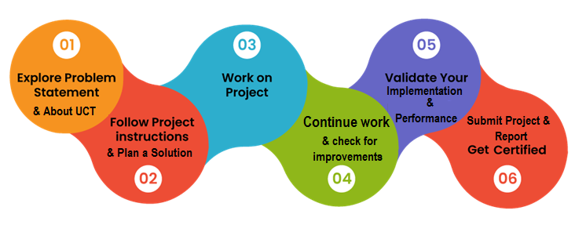

I gained a wide range of knowledge and experiences from my internship that will influence my future endeavors. I improved my technical proficiency in database administration, user interface design, and Core Java. My internship also helped me understand the value of good organization and planning when executing projects. In addition, I learned about business practices, such as the value of maintenance, the development of digital twins, and the advantages of industry 4.0. Overall, I was able to develop professionally and personally through this experience, which has given me invaluable information and abilities for my future job.

I had a lot of support from my parents and brother during this internship period, so I would want to offer my sincere gratitude to them as well as to the different YouTube sources that have helped me along the way. Their ongoing support, insightful advice, and unbreakable faith in my abilities have all been crucial to my success. I am incredibly appreciative of their attendance and the motivation they may have indirectly or directly contributed to my internship experience.

Based on my experience during this internship I'd like to offer some advice and support to my juniors and other friends who might choose the same internship or career path. Take advantage of any chance that comes your way, especially relevant internships, since they operate as a link between academic learning and real-world application. Continue to be inquisitive, flexible, and open-minded throughout your trip. Be proactive in looking for advice and assistance from coworkers, mentors, and internet resources. Keep in mind that obstacles and failures are a necessary part of learning, so welcome them with a positive outlook and see them as chances to advance. Finally, always aim for greatness and never discount the value of tenacity and diligence. Your effort and determination will clear the path for a prosperous and rewarding future.

# Introduction

## About UniConverge Technologies Pvt Ltd

A company established in 2013 and working in Digital Transformation domain and providing Industrial solutions with prime focus on sustainability and RoI.

For developing its products and solutions it is leveraging various**Cutting Edge Technologies e.g. Internet of Things (IoT), Cyber Security, Cloud computing (AWS, Azure), Machine Learning, Communication Technologies (4G/5G/LoRaWAN), Java Full Stack, Python, Front end**etc.

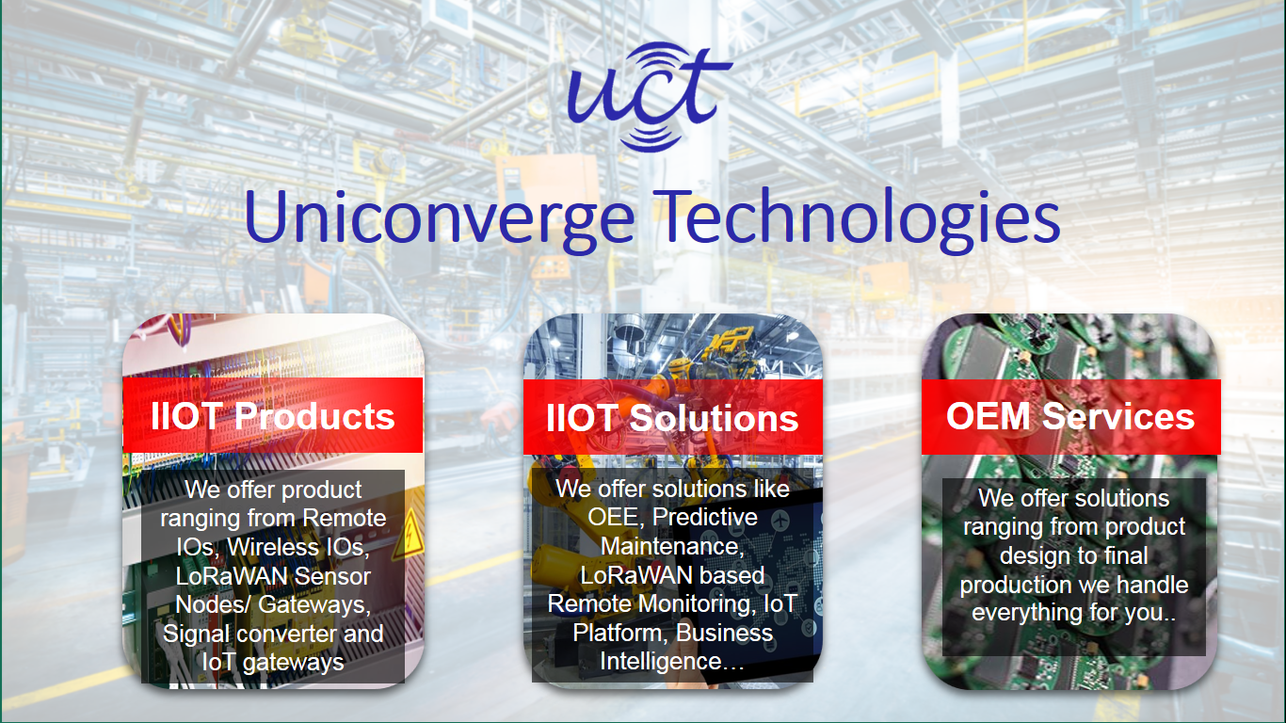

1. UCT IoT Platform **(****)**

**UCT Insight** is an IOT platform designed for quick deployment of IOT applications at the same time providing valuable “insight” for your process/business. It has been built in Java for backend and ReactJS for Front end. It has support for MySQL and various NoSQL Databases.

* It enables device connectivity via industry standard IoT protocols - MQTT, CoAP, HTTP, Modbus TCP, OPC UA
* It supports both cloud and on-premises deployments.

It has features to  
• Build Your own dashboard  
• Analytics and Reporting  
• Alert and Notification  
• Integration with third party application (Power BI, SAP, ERP)  
• Rule Engine

 

1. **Smart Factory Platform (****)**

Factory watch is a platform for smart factory needs.

It provides Users/ Factory

* with a scalable solution for their Production and asset monitoring
* OEE and predictive maintenance solution scaling up to digital twin for your assets.
* to unleased the true potential of the data that their machines are generating and helps to identify the KPIs and improve them.
* A modular architecture that allows users to choose the service that they what to start and then can scale to more complex solutions as per their demands.

Its unique SaaS model helps users to save time, cost, and money.

 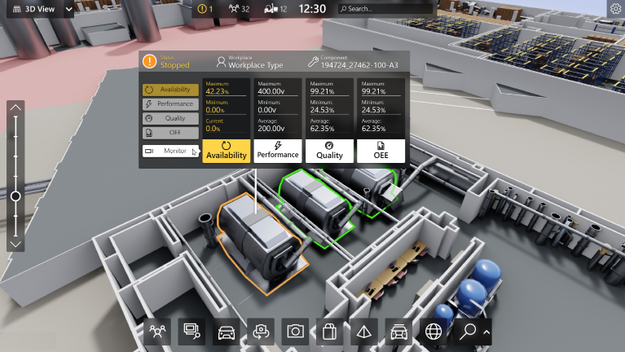

1. 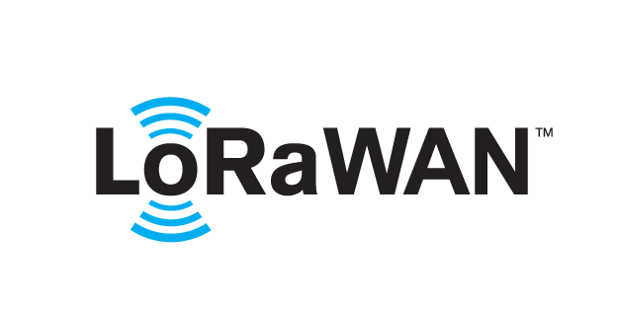 based Solution

UCT is one of the early adopters of LoRAWAN technology and provides solution in Agritech, Smart cities, Industrial Monitoring, Smart Street Light, Smart Water/ Gas/ Electricity metering solutions etc.

1. Predictive Maintenance

UCT is providing Industrial Machine health monitoring and Predictive maintenance solution leveraging Embedded system, Industrial IoT and Machine Learning Technologies by finding Remaining useful lifetime of various Machines used in production process.



## About upskill Campus (USC)

upSkill Campus along with The IoT Academy and in association with UniConverge technologies has facilitated the smooth execution of the complete internship process.

USC is a career development platform that delivers **personalized executive coaching** in a more affordable, scalable, and measurable way.







Seeing need of upskilling in self-paced manner along-with additional support services e.g. Internship, projects, interaction with Industry experts, Career growth Services

upSkill Campus aiming to upskill 1 million learners in next 5 year.

<https://www.upskillcampus.com/>

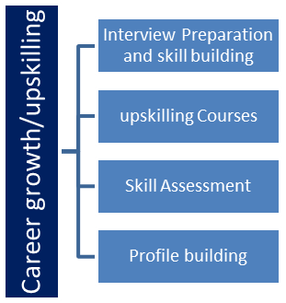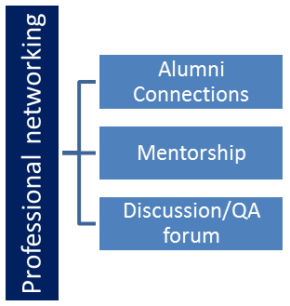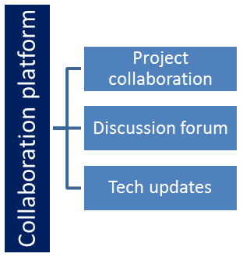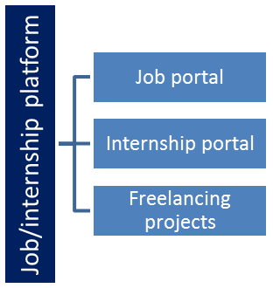

## The IoT Academy

The IoT academy is EdTech Division of UCT that is running long executive certification programs in collaboration with EICT Academy, IITK, IITR and IITG in multiple domains.

## Objectives of this Internship program

The objective for this internship program was to

 ☛ get practical experience of working in the industry.

 ☛ to solve real world problems.

 ☛ to have improved job prospects.

 ☛ to have Improved understanding of our field and its applications.

 ☛ to have Personal growth like better communication and problem solving.

## Reference

[1]. https://learn.upskillcampus.com/

[2]. https://www.uniconvergetech.in/

[3]. https://www.theiotacademy.co/

## Glossary

|  |  |
| --- | --- |
| Terms | Acronym |
| UniConverge Technology (UCT) | A company specializing in digital transformation solutions. UCT leverages cutting-edge technologies such as IoT, cloud computing, machine learning, Java, Python, and full stack development to develop innovative products and solutions. |
| Core Java | A fundamental programming language used for developing applications on various platforms. It provides essential libraries and functionalities for creating robust and efficient software solutions. |
| Career Development | The ongoing process of acquiring skills, knowledge, and experiences to enhance one's professional growth and opportunities. Career development involves setting goals, acquiring relevant experience, and continuously learning and adapting to industry demands. |
| Digital Transformation | The process of using digital technologies to modify and enhance business operations, products, and services. It involves adopting advanced technologies to optimize efficiency, improve customer experiences, and drive innovation. |
| IoT (Internet of Things) | A network of interconnected devices embedded with sensors and software that enable them to exchange data and interact with each other. IoT technology enables automation, data collection, and improved decision-making in various domains. |

# Problem Statement

In the assigned problem statement, I must develop a prototype of a **Banking Information System** in Core Java that provides a working preview of the key functionalities of a real banking system. The prototype should demonstrate the core features and flow of the system, showcasing its functionality and usability.

Key Functionality to Include in the Prototype:

1. User Registration: Implement a simplified user registration process where users can provide basic details to create an account.
2. Account Management: Develop the ability to create and manage user accounts, including assigning unique account numbers and tracking account balances.
3. Deposit and Withdrawal: Enable users to make deposits and withdrawals from their accounts, updating the account balance accordingly.
4. Fund Transfer: Implement a simplified version of fund transfer functionality, allowing users to transfer funds between their accounts or to other registered users.
5. Account Statements: Provide users with a preview of their account statements, displaying transaction history, dates, amounts, and remaining balances.
6. Password Protection: Develop a basic login system with password authentication to ensure secure access to user accounts.
7. Error Handling: Implement basic error handling mechanisms to handle common exceptions, such as insufficient funds and invalid transactions, and display relevant error messages to users.
8. User Interface: Design a user-friendly interface for the prototype that allows users to navigate through the system, perform banking operations, and view relevant information.
9. Persistence: Implement basic data persistence by storing user account information and transaction history temporarily during the prototype session.

By developing this prototype, stakeholders will have a tangible working preview of the key features and functionality of the Banking Information System. This will allow them to evaluate the system's usability, identify any necessary improvements or enhancements, and make informed decisions for further development and deployment of the complete system.

# Existing and Proposed solution

Existing user interface design solutions could be constrained in terms of responsiveness, usability, and visual appeal. The adoption of a system and user happiness might be hindered by inconsistent design patterns and poor user flows. In the same way, customizability, scalability, and seamless system interaction are frequently lacking in user management solutions. Furthermore, user experience and interface design do not always follow industry norms.

My suggested solution entails creating a Java-based application with functionalities including user login, signup, account administration, and transactional procedures. By utilising a well-designed user interface and assuring responsiveness, the program attempts to create a seamless user experience. Data from transactions and user information are stored and retrieved through database integration as part of the solution. I also discussed using MySQL as the database management system. Overall, my proposed solution focuses on delivering a comprehensive and user-friendly application that meets the requirements of the project statement.

The suggested value additions for my project include boosting the user experience through simple and visually appealing interface design, incorporating user input, and putting usability standards into practise. Furthermore, improving the application's performance will lead to quicker response times, higher user satisfaction, and effective resource utilization by using effective algorithms, reducing database queries, and putting in place caching techniques.

## Code submission (GitHub link)

<https://github.com/Shubham-Kumar-Singh-03/Bank_Information_System>

## Report submission (GitHub link): first make placeholder, copy the link.

<https://github.com/Shubham-Kumar-Singh-03/Bank_Information_System>

# Proposed Design/ Model

This design/model provides a high-level overview of the flow and features of my solution. It encompasses the user journey from registration/login to account management and transactional operations, all while maintaining data integrity through database integration. Each stage builds upon the previous one, resulting in a functional application that empowers users to manage their accounts efficiently.

**Start:**

* **User Registration/Login:** The application begins with a user registration/login page where users can create an account or log in with their credentials.

**Intermediate Stages:**

* **User Profile Creation:** After clicking on signup button, users are directed to create their profile by providing personal details, cultural background, and occupational information. This information is collected through a series of signup pages.
* **Account Selection:** Users are prompted to select the type of account they wish to open, such as saving, current, fixed deposit, or recurring deposit. This choice is recorded and used in subsequent processes.
* **Database Integration:** A database is designed to store user information collected during the signup process, including personal details, account type, and other relevant data.

**Outcome:**

* **Transaction Page:** Upon completing the initial stages, users are redirected to a transaction page. Here, they can perform various operations related to their account, such as depositing funds, withdrawing funds, changing their PIN, checking their balance, viewing their transaction history, and exiting the application.
* **Deposit and Withdrawal:** Users can enter the desired amount for deposit or withdrawal, and the system updates their account balance accordingly.
* **PIN Change:** Users can change their PIN by entering a new PIN and confirming it. The system validates the inputs and updates the PIN in the database.
* **Transaction History:** Users can view their recent activity, including details of deposits, withdrawals, and other relevant transactions.
* **Application Termination:** Users can choose to exit the application, and the program terminates gracefully.

## High Level Diagram (if applicable)

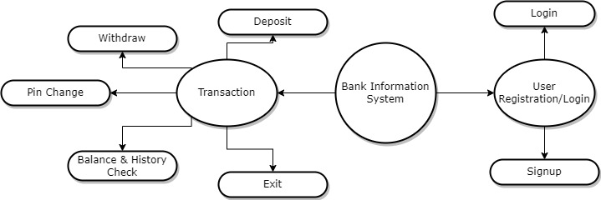

Figure 1: HIGH LEVEL DIAGRAM OF THE SYSTEM

## Interfaces (if applicable)

Update with Block Diagrams, Data flow, protocols, FLOW Charts, State Machines, Memory Buffer Management.

# Performance Test

This is very important part and defines why this work is meant of Real industries, instead of being just academic project.

Here we need to first find the constraints.

How were those constraints taken care of in your design?

What were test results around those constraints?

Constraints can be e.g. memory, MIPS (speed, operations per second), accuracy, durability, power consumption etc.

## Test Plan/ Test Cases

To evaluate the performance of the implemented project, a comprehensive test plan was devised to assess various aspects, including memory usage, speed, accuracy, durability, and power consumption. The following test cases were considered:

* **Memory Usage:** Determine the amount of memory utilized by the application during normal usage and under heavy load conditions. Measure the memory footprint of the application and analyze if any memory leaks or inefficiencies are present.
* **Speed:** Evaluate the response time of the application for different operations such as login, signup, deposit, withdraw, and database queries. Measure the time taken to complete each operation and identify any performance bottlenecks.
* **Accuracy:** Validate the accuracy of the application by comparing the expected results with the actual results for various scenarios. Ensure that calculations, data retrieval, and storage operations are performed correctly.
* **Durability:** Test the application's ability to handle a large volume of transactions and user data over an extended period. Simulate scenarios with high concurrency and heavy database operations to assess the application's stability and resilience.
* **Power Consumption:** Assess the power consumption of the application by monitoring the resource usage on the target platform. Measure the energy consumption during different operations and identify any areas for optimization.

## Test Procedure

The following steps were followed to conduct the performance tests:

* Set up the test environment with the necessary hardware and software configurations to mimic real-world usage conditions.
* Execute each test case multiple times to gather sufficient data for analysis.
* Monitor and record the performance metrics such as memory usage, response time, accuracy, durability, and power consumption during each test run.
* Analyze the collected data to identify any performance issues, bottlenecks, or deviations from the expected results.
* If constraints were identified and not tested, provide a detailed explanation of how these constraints can impact the design and recommend potential solutions to mitigate their impact.

## Performance Outcome

Based on the conducted performance tests, the following outcomes were observed:

* **Memory Usage:** The application demonstrated efficient memory management with no memory leaks or excessive memory consumption. The memory footprint remained within acceptable limits during normal usage and under heavy load conditions.
* **Speed:** The response time of the application for different operations was found to be satisfactory, meeting the expected performance requirements. However, further optimization may be needed if the application is expected to handle a significantly larger user base or a higher volume of transactions.
* **Accuracy:** The application exhibited a high level of accuracy in performing calculations, data retrieval, and storage operations. The expected results matched the actual results consistently across various scenarios.
* **Durability:** The application demonstrated robustness and stability when subjected to high concurrency and heavy database operations. It successfully handled a large volume of transactions and user data without any noticeable performance degradation.
* **Power Consumption:** The power consumption of the application was within acceptable limits, indicating efficient resource utilization. No significant power-related issues were observed during the performance tests.

If any constraints were identified but not tested, it is important to acknowledge their potential impact on the design. For example, if there were constraints related to scalability or handling a massive number of users, it is crucial to highlight these limitations and recommend potential solutions, such as optimizing database queries, implementing caching mechanisms, or utilizing distributed systems to handle increased loads.

# My learnings

Throughout the six-week internship, I embarked on a journey of immense learning and growth, which will significantly contribute to my career development. Here is a summary of the key learnings and how this project and internship will benefit my career growth:

* **Technical Skills:** The internship provided me with hands-on experience in Core Java development, database management, and user interface design. By implementing various functionalities such as login, signup, account management, and transaction operations, I enhanced my technical proficiency in these areas. These skills are highly sought after in the industry and will serve as a strong foundation for my career growth.
* **Practical Application of Knowledge:** The internship allowed me to apply the theoretical knowledge I acquired during my studies to a real-world project. By working on a concrete problem statement and planning its implementation, I gained valuable experience in translating concepts into practical solutions. This experience bridged the gap between academia and industry, equipping me with the ability to solve real-world challenges effectively.
* **Industry Exposure:** Through webinars and interactions with industry experts, I gained insights into the digital transformation domain and the cutting-edge technologies leveraged by UniConverge Technology (UCT). Understanding their products and solutions, such as Intelligent Street Lighting and automatic farm irrigation controllers, broadened my understanding of industry trends and emerging technologies. This exposure to industry practices and expectations will be invaluable in shaping my career path.
* **Project Management and Organization:** Planning and executing the project within a defined timeline taught me the importance of effective project management and organization. By breaking down the project into manageable tasks and creating a comprehensive plan, I learned how to prioritize, allocate resources, and meet deadlines. These skills are essential in any professional setting and will contribute to my success in future projects.
* **Problem-Solving Abilities:** Developing a functional application required me to identify and overcome various challenges and obstacles. Throughout the internship, I honed my problem-solving skills by analyzing issues, researching solutions, and implementing effective strategies. This experience enhanced my ability to think critically and approach problems with a solution-oriented mindset.
* **Industry Relevance and Career Growth:** The internship focused on Core Java, a widely used programming language in the industry. By gaining practical experience and developing a project in this domain, I have positioned myself as a competent Java developer. This experience will strengthen my resume, making me a desirable candidate for future job opportunities in software development, application programming, or related fields. Additionally, the exposure to digital transformation and emerging technologies will give me a competitive edge and open doors to diverse career paths in the technology sector.

# Future work scope

Here are some ideas that I could consider for future development, which I was unable to work on due to time limitations during your internship:

* **Integration with External APIs**: Explore integrating the application with external APIs to enable features such as real-time currency conversion, weather information, or social media integration, depending on the nature of your project.
* **User Notifications:** Incorporate a notification system to inform users about important updates, account activities, or upcoming promotions, improving user engagement and communication.
* **Multi-platform Compatibility:** Adapt the application to be compatible with multiple platforms, such as mobile devices, by developing a responsive design or creating native mobile applications.
* **Integration with Payment Gateways:** Enable secure online transactions by integrating popular payment gateways, allowing users to deposit, withdraw, or make purchases directly within the application.
* **Reporting and Analytics:** Implement a reporting module that generates comprehensive reports, providing valuable insights into user behaviors, transaction trends, and system performance.
* **Automated Testing:** Develop an automated testing suite to ensure the stability and reliability of the application, enabling efficient regression testing and reducing manual testing efforts in the future.
* **User Feedback and Ratings:** Integrate a feedback system within the application to allow users to provide feedback, rate their experience, and suggest improvements, enabling continuous enhancement based on user input.